# Class 6 – Optimization – Linear Programming – 2017-09-25

Reading 6 – (p415-441), Skim Ch 14, Online Supp. Ch A p 1-18

|  |  |
| --- | --- |
| Focus: | * Understand LP and applications/Recognize when Math Programming is appropriate * Formulate & solve basic problems with software (Excel, Solver, etc)/Develop basic Linear Models * Computer Solution: Excel, Solver, etc * Interpret sensitivity output with software |

**Introduction:**

* **Mathematical Models**: Representation of situations; drawing conclusions about real situations by studying & analyzing model
  + Models are cheaper, quicker, less risky and more feasible than actual situation; however, they are a simplification of reality
  + A model that seeks the “right answer to the wrong question” is of no value
* **Math Programming**: Maximize or Minimize an objective to certain constraints
  + Types: **Linear**, Integer, Mixed, Nonlinear, Goal
* **Definitions**
  + **Feasible Solution:** one that **satisfies all constraints** – **can have many** feasible solutions
  + **Feasible Region: set** of all feasible solutions
  + **Optimal Solution:** any **Feasible Solution** that optimizes the objective function (can have “ties”)
* **Applications**
  + **Operations:** Diet, production planning, blending, transportation, product mix (which order should ship from which outlet)
  + **Marketing:** Media selection, marketing research
  + **Finance:** Portfolio selection, financial planning, “efficient frontier”
  + **HR:** workforce assignment (what its worth to renegotiate union contracts – ie overtime)
  + **Other:** Revenue management, data envelope analysis (compare efficiencies of multiple units)
  + **War Games:** Optimal way of bombing a submarine
* **Key Questions for Building LP**
  + What am I trying to decide?
  + Is objective to Minimize or Maximize?
  + What are the constraints? Limitations or Requirements; Explicit or Implicit?

|  |
| --- |
| **Class Notes**   * We do not want to minimize cost – we want to maximize contribution or profit! * No point looking at sensitivity analysis report – just re-compute! * Graphical solution to 2D problems are no long relevant – too simple! |

**Creating a Linear Program**

1. **Formulate Linear Program**
   1. Identify/Define **Decision Variables:** The unknown values the model seeks to determine (what do you really want to know)
      1. Can assume **any factional value** (ie continuous) and **non-negative**,
         * In practice continuous variables may not be possible, but assumed OK for now
      2. Variables appear on the **left hand side (LHS) of the constraint function** and constants appear on the **right hand side (RHS) of the constraint function**
   2. Identify 1 **Objective Function**: The quantity we seek to Maximize or Minimize
      1. Linear Function
   3. Identify **Constraints**: Limitations, requirements or restrictions imposed on the solution (what are the resources)
      1. Must include non-negative constraints
      2. LHS relates to DV from OF; RHS numerical values

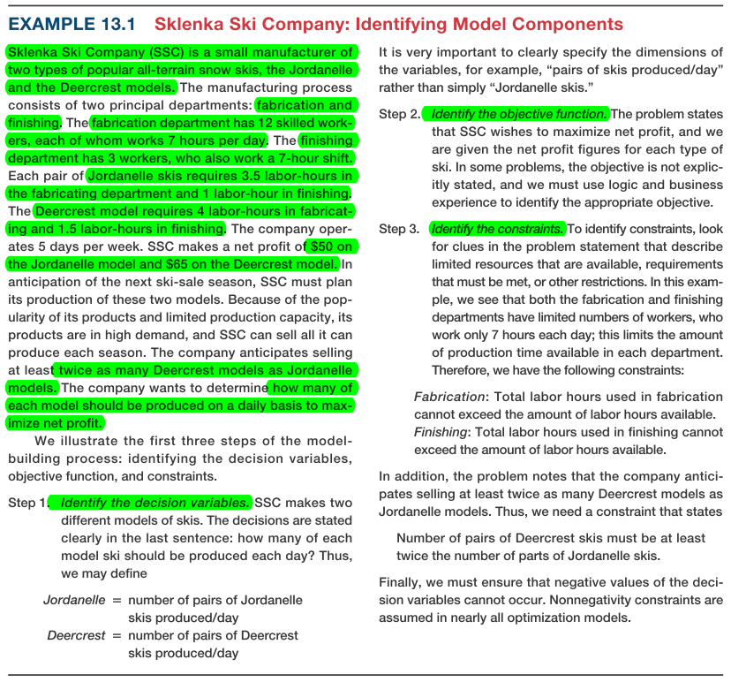

* 1. Write **Objective Function** and **Constraints** as linear functions
     1. Objective function written as f(DV)
     2. Constraints expressed as equalities: **=, Surplus (≥), or Slack (≤)**

|  |
| --- |
| **Objective Function:** Maximize Total Profit = 50 J + 65 D  **Constraints**: Fabrication: 3.5J + 4D <= 84; Finishing: 1J + 1.5 D <= 21; Double the amount of Deercrest: D – 2J >= 2; D >=0; J >=0 |

1. **Graph**
   1. Constraint Functions
   2. Objective Function

|  |
| --- |
| **Spreadsheet Engineering Guidelines for Designing Spreadsheet Models for Optimization Problems**   1. Put the objective function coefficients, constraint coefficients, and right-hand values in a logical format in the spreadsheet. For example, you might assign the decision variables to columns and the constraints to rows, much like the mathematical formulation of the model, and input the model parameters in a matrix. If you have many more variables than constraints, it might make sense to use rows for the variables and columns for the constraints. 2. Define a set of cells (either rows or columns) for the values of the decision variables. In some models, it may be necessary to define a matrix to represent the decision variables. The names of the decision variables should be listed directly above the decision variable cells. Use shading or other formatting to distinguish these cells. 3. Define separate cells for the objective function and each constraint function (the left-hand side of a constraint). Use descriptive labels directly above these cells   **Avoid Functions: ABS, MIN, MAX, INT, ROUND, IF, and COUNT** |

1. **Find Solution:** Using Solver: “Data” Tab 🡪 “Solver”

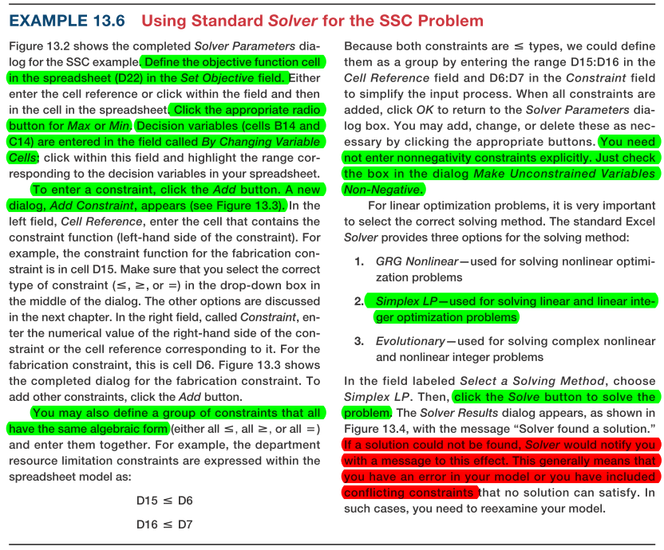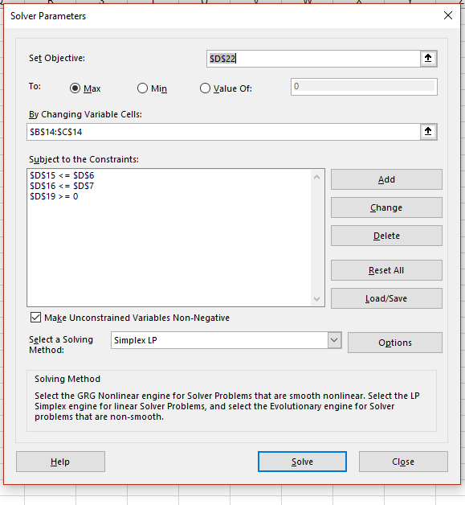

1. **Simplex Approach (Answer Report)**

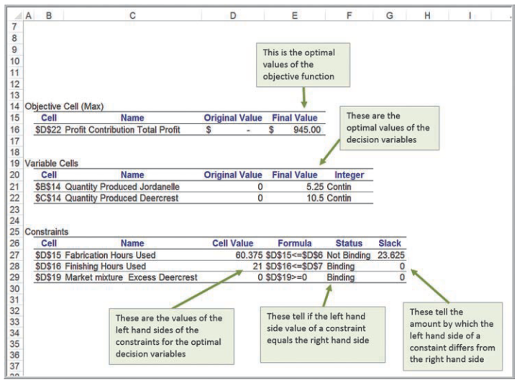

* Note: Solver will name cells be using the first cell to the left and the first cell above that contains text 🡪 Arrange the problem accordingly to allow for easy interpretation of the results
* **4 Solver Outcomes:**

1. **Unique Optimal Solution**: Exactly one solution that results in max/min objective
2. **Alternate Optimal Solution:** Objective is maximized/minimized by more than one combination of decision variables 🡪 Solver does not tell you when alternative solutions exist; however, you can use the sensitivity report to identify existence of alt. solutions (Allowable Increase/Allowable Decrease **=** 0 🡪 Alternative solutions exist)
3. **Unbounded Problem**: Value of objective function can be increased/decreased without bound (ie ±∞)
   * Indicates a constraint has been left out
4. **Infeasible Problem:** No feasible region (example: demand requirement is higher than available capacity)

* **The Optimal Solution will include:** Decision Variables: basic (non-zero value; in the solution), and non-basic (zero; not in the solution); Values of Decision Variables; Objective Function Value (OFV)

**IGNORE SENSITIVITY ANALYSIS – FASTER TO RECALCULATE!!!!**

**Sensitivity Analysis**

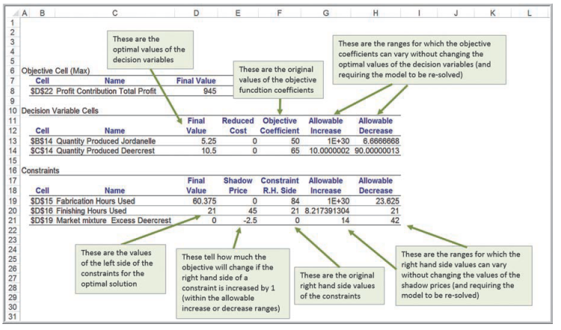

**Sensitivity Report** (Changes outside of the range 🡪 must resolve)

* Info applied to moving Objective Function coefficients or RHS Coefficients 1 at a time 🡪 Ask “What If”
* **Decision Variable Cells:**
  + **Reduced Cost:** How much the objective coefficient needs to be improved (increase for max, decrease for min)for non-negative variable that is 0 in optimal solution to become positive (ie become a factor); If the variable is positive, reduced cost is always 0; “could enter” is a tie between basic/non-basic
  + **Allowable Increase/Decrease:** How much the coefficients can vary without changing optimal decision variable values & reduced cost (usually still a change in “Final Value”)
* **Constraints**:
  + **Shadow Price:** How much the solution will change if the RHS of the constraint is increased (+ve) or decreased (-ve) by 1 (ie when a constraint involves a limited resource, Shadow Price = economic value of having an additional unit of that resource); when there is positive slack (ie non-binding), Shadow Price = 0
  + **Allowable Increase/Decrease**: How much RHS of the constraint can change w/o changing the shadow price
* Important to managers who operate in dynamic environments with imprecise estimates 🡪 how accurate does the data need to be?
* **Using The Sensitivity Report: Impact of Changes**
  + Change in Objective Function 🡪 Change Optimal Solution
  + Change Existing Constraint Right Hand Side (RHS) 🡪 Changes Slope, Size of Feasible Region
  + Add New Constraint 🡪 Decrease Feasible Region if Binding
  + Remove Constraint 🡪 Increase Feasible Region if Binding
  + Add a Variable to OF 🡪 Re-solve, No sensitivity analysis can be done
  + Change Coefficients on LHS of constraint 🡪 Re-solve, No sensitivity analysis can be done
* **Constraints**
  + **Tightening Constraints:** Decreasing RHS of a ≤ constraint; compresses feasible region, can make solution worse
  + **Relaxing Constraints:** Increasing RHS of a ≥ constraint; expand feasible region, can improve solution
* **Sunk vs Relevant Costs**
  + **Sunk Costs:**  No charge for additional resources – already available
  + **Relevant Cost:** Charge for additional material – need to subtract relevant cost per unit from shadow price for net profit increase

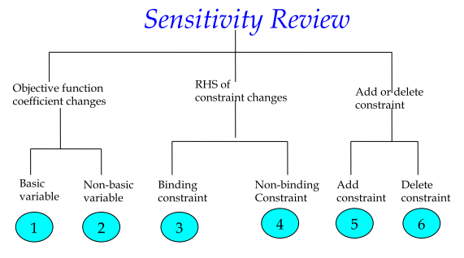

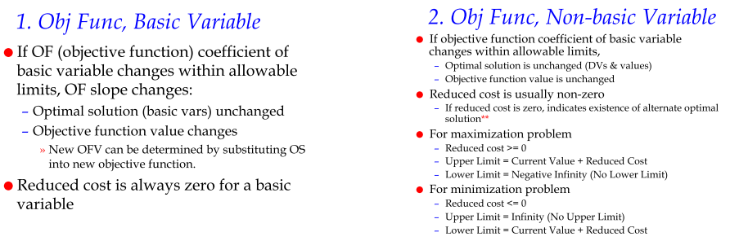

**\*\*\* If reduced cost is zero indicates existence of alternate optimal solutions????**

